You’re Doomed

Press Kit

Welcome to the press kit for You’re Doomed. Here you can find all information and resources related to both You’re Doomed and the developer Black Dragon Studios Ltd. For the purpose of evaluating and reviewing the game.

Fact Sheet

- Developer: Black Dragon Studios, based in Swansea, UK

- Website: www.blackdragon-studios.com

- Release: Q4 2019 (Windows 7 / Windows 10 / Xbox One / PS4)

- Platforms: Microsoft Windows, Xbox One, PS4

- Price: £11.99 (UK)
$14.99 (USA)
€12.50 (EU)

- Rating: TBC

- Contact: devteam@blackdragon-studios.com

- Social: Twitter: @BlackDragonDev
https://www.facebook.com/BlackDragonDev
https://www.instagram.com/blackdragonstudios_official/
https://discord.gg/88sNDNE
Twitter: @YoureDoomedGame
https://www.facebook.com/YoureDoomedGame
https://www.instagram.com/YoureDoomedGame
Description

The player controls one of four surviving crew members on the HMSS Robert Falcon Scott, a science spaceship exploring the galaxy. The HMSS Robert Falcon Scott has been infected and crew mutated the player(s) must fight their way through the ship and escape before the computer destroys the ship. The game is played from a top down perspective and can be played with as couch co-op1 to 4 players.

You’re Doomed is being designed for an instant gratification gameplay style and for an audience who expects to be entertained with the simple click of a button. This gameplay style will feature quick drop in and drop out multiplayer, intense feedback and fast paced action.

The multiplayer gameplay is being created as a competitive co-operative mode where players will have to work together to defeat all of the enemies and escape the level, however they will be in competition with each other through-out for high-scores, multipliers, and power-ups. This multiplayer mode is also being designed to allow players to quickly drop in and drop out of a game and get right into the action, reducing the time between a player picking up a controller and playing the game to just seconds.

A pre-alpha discord group for testing and feeding back on the game is open and available to the public at this address: https://discord.gg/88sNDNE

Features

- Couch co-op gameplay, for up to four players
- Single player and co-op campaign
- Competitive co-op design
- 8 unique and over the top weapons
- Player controlled weapon upgrades and special attacks
- Old school twin-stick gameplay
- Massive enemy hordes

Narrative Synopsis:

The game takes place on a planet sized spaceship, the HMSS (Her Majesty’s Space Ship) Robert Falcon Scott, this is a scientific and exploration vessel designed to explore the galaxy.

After a night of partying to celebrate Ruby paying off her student debt (age: 96, occupation: security guard), four members of the Robert Falcon Scott’s security team wake up near the ship’s core, in an engineering deck locker room to discover the ship has been overrun with an infection and the crew mutated. They must fight their way through the ship to the surface and escape pods before the ship’s computer (who’d really like to escape too!) flies the Robert Falcon Scott into the nearest star.

Gameplay Summary:

You’re Doomed is played from a top down perspective, so the player(s) can see each other and enemies around them.

The primary control method is through a gamepad, where one analogue stick is used to aim (rotate) the player’s character and the other analogue stick is used to move the player character, The game can also be played with a keyboard and mouse (on PC/Mac).
As the player moves between each room on the ship they will be faced with large enemy hordes, which they must clear before they can proceed with the level. The game features fast paced and intense action, with a large volume of feedback being driving to the player(s), both on screen and through the gamepad.

The game’s scoring system gives each player a set amount of points for killing an enemy, however these points can be augmented by multiplier which the enemies drop upon injury and any player can collect. The player’s weapon is also linked to this system, as the player’s multiple increases the weapon upgrades passing through several major and intermediary steps.

One of the core elements of You’re Doomed’s gameplay is ‘Competitive Co-op’, where players must work together to get through the level but are in competition with each other for points and multipliers. Although the game can be played as a single player experience, multiplayer is also at the core of You’re Doomed. The game will feature both local and online multiplayer modes. There will however be a parity of design between all the game modes (single, local, and online multiplayer), i.e. the game will largely be played in the same way.

This game is designed to be a fast paced, action orientated experience, with the central design philosophy of instant gratification. It is being designed so that the time between picking up a game controller and being in the action is only a few seconds.

You’re Doomed Screenshots

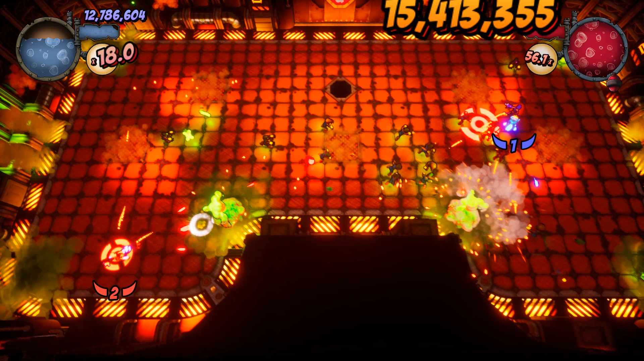
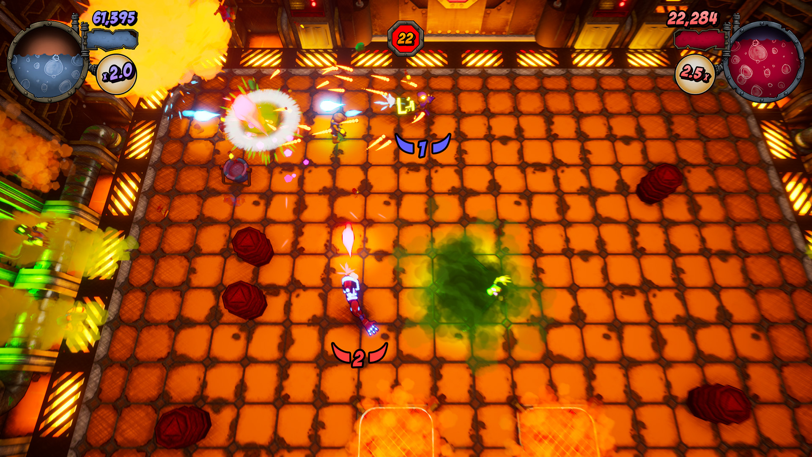
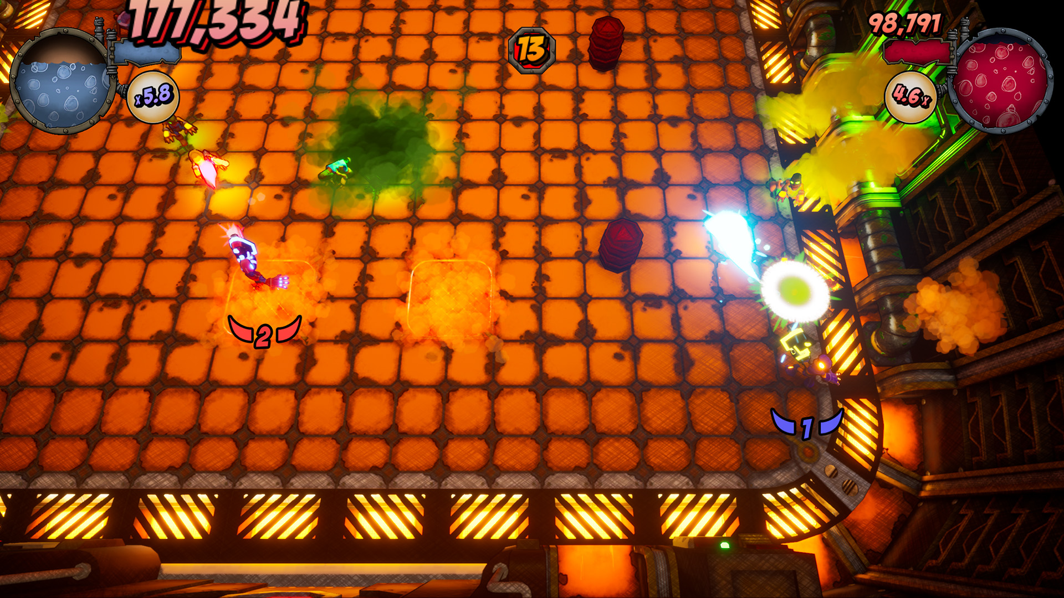
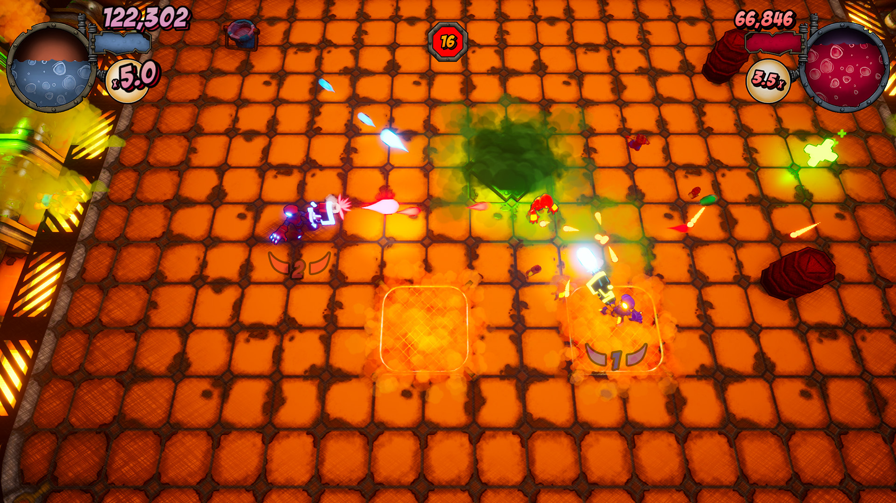
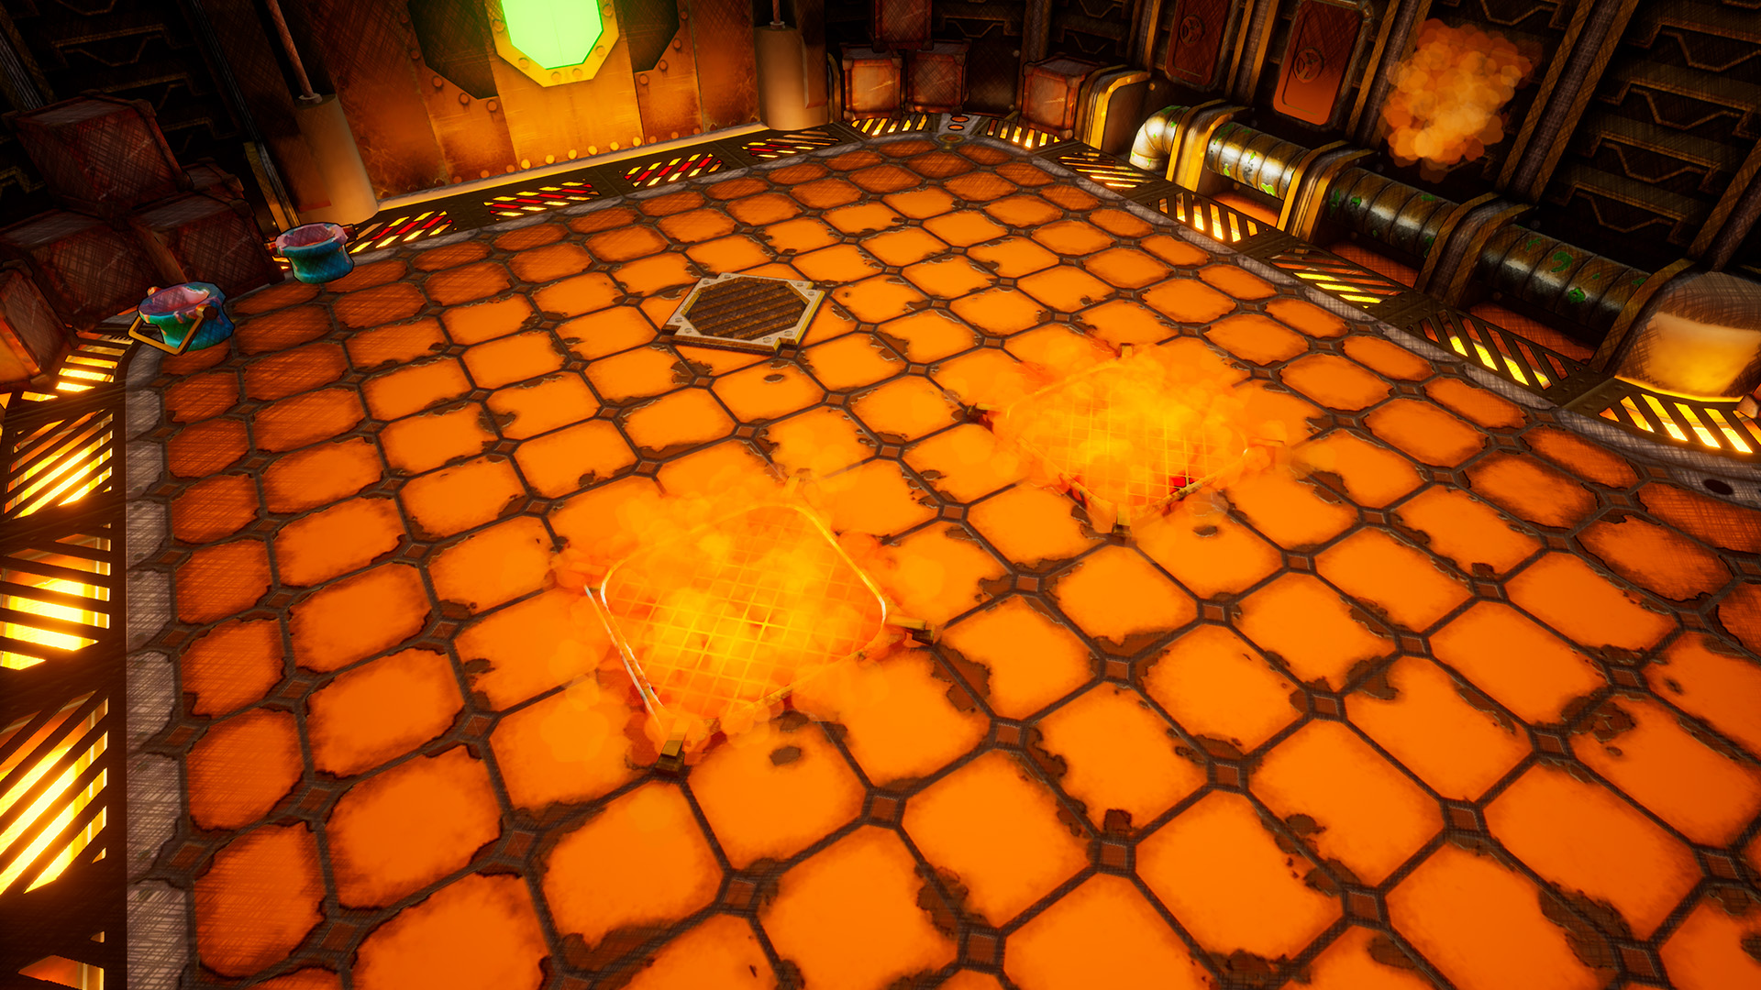
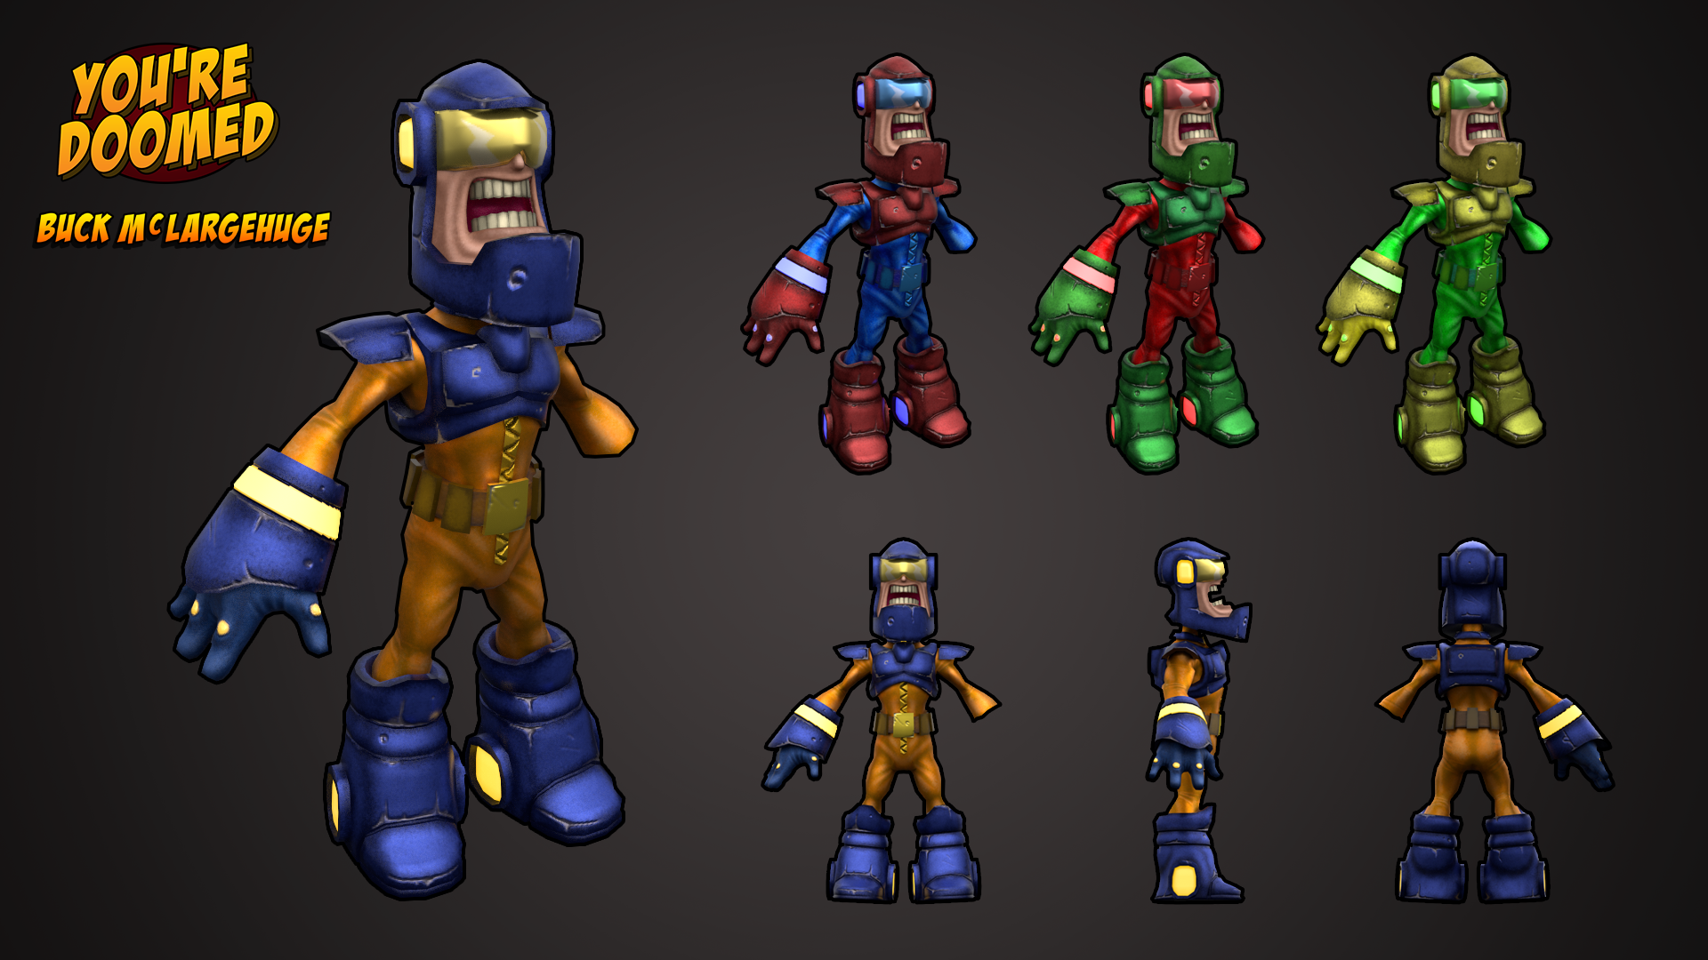

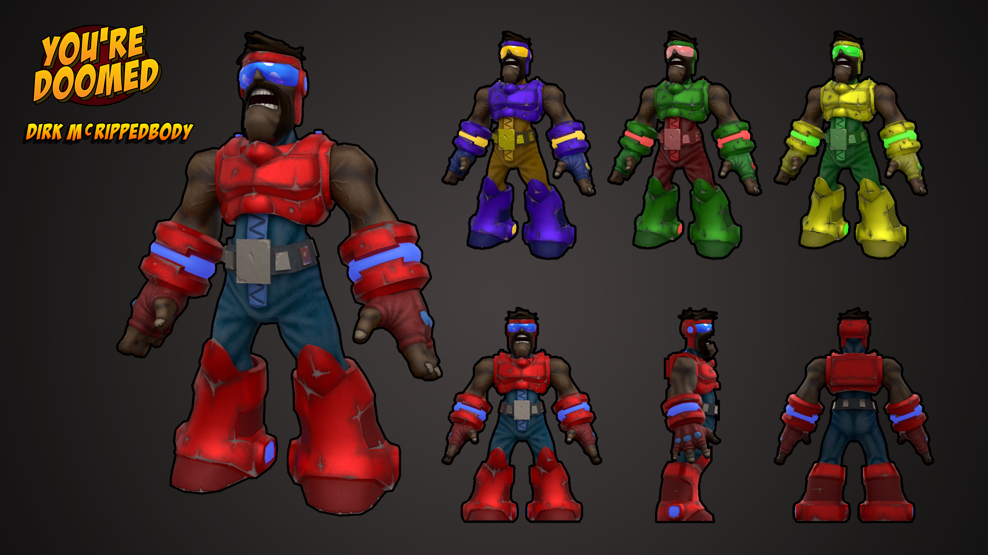
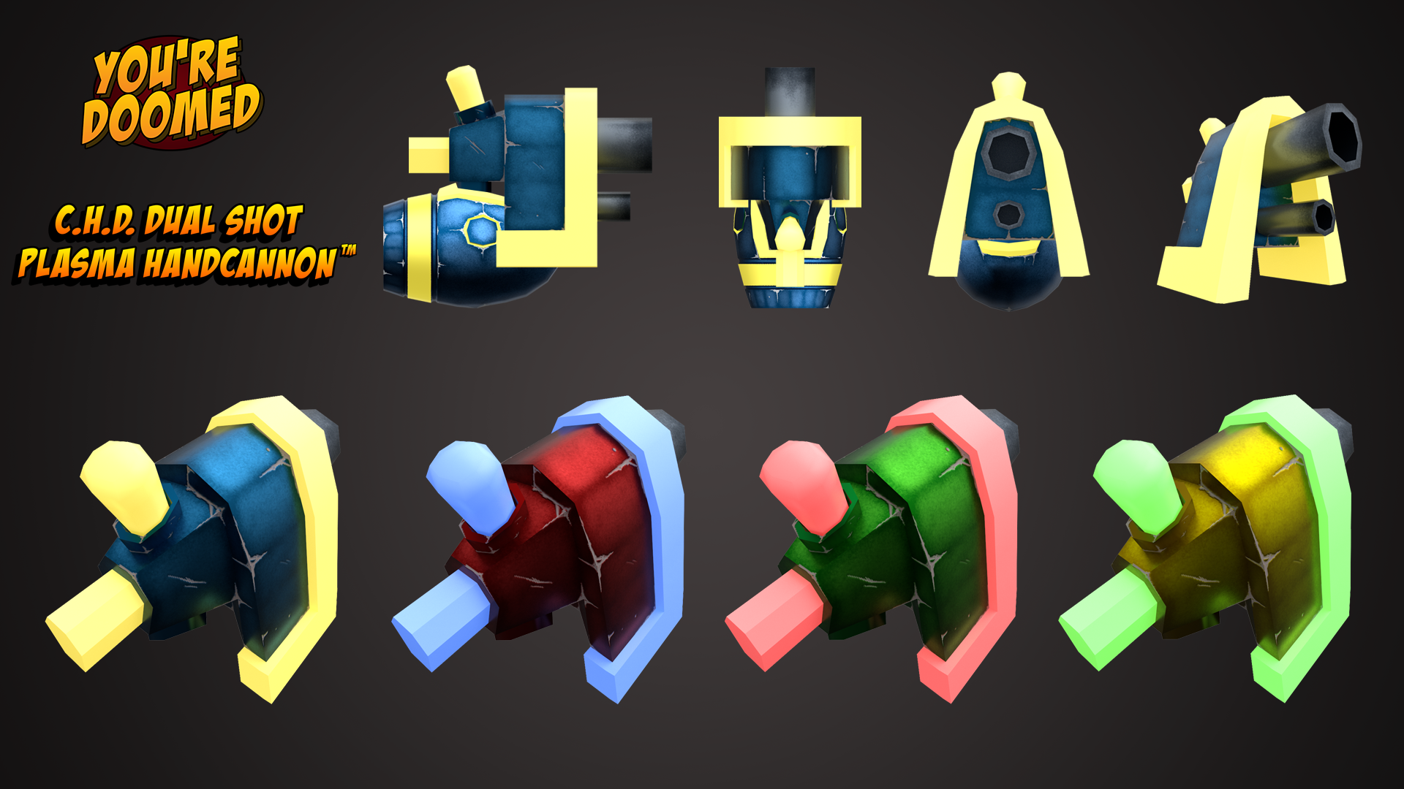

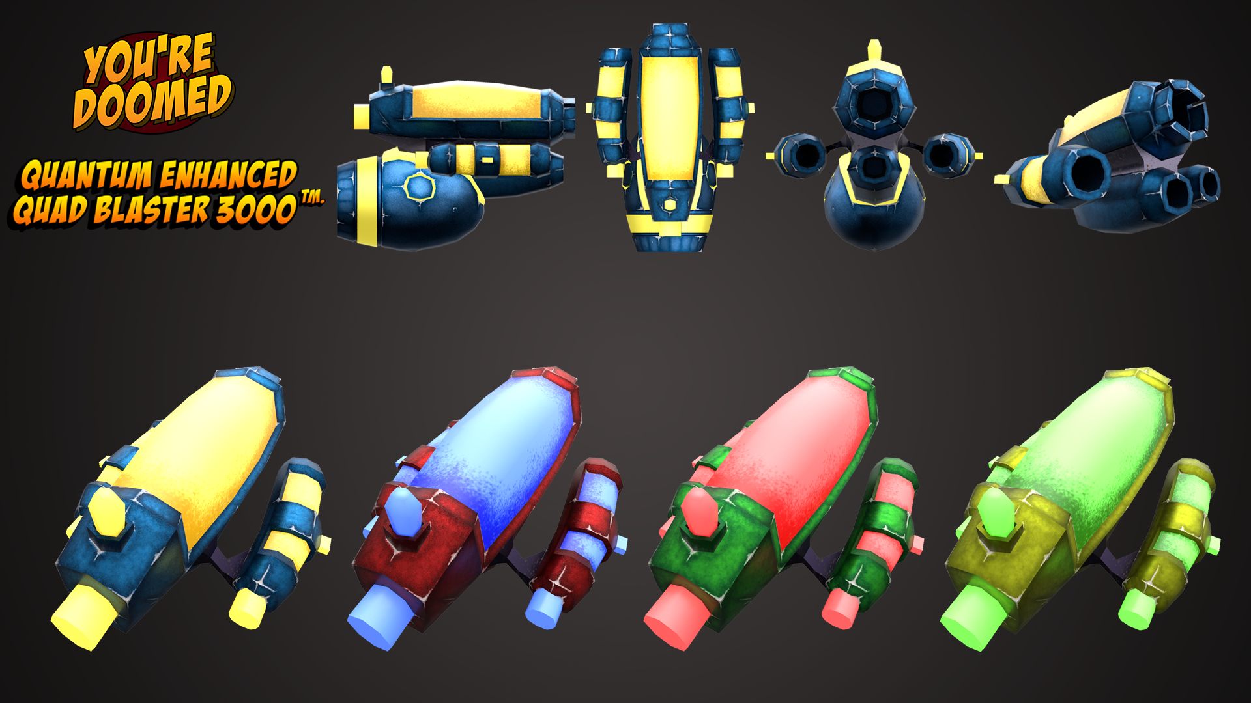
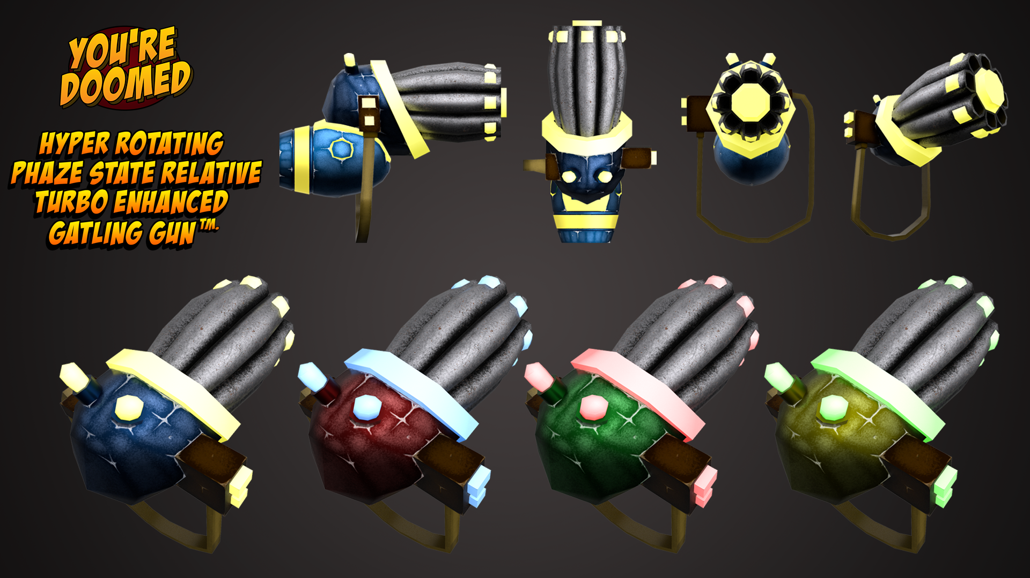

Screenshot download here (more extensive selection available for download)

You’re Doomed videos

You’re Doomed Pre-Alpha Trailer

You’re Doomed Pre-Alpha Gameplay video

Logos

Below is a selection of useful game and studio logos for use in reviews or features:

Black Dragon Studios overview

Formed in September 2018, Black Dragon Studios is a fully independent games developer. As a studio we create virtual and augmented exhibitions, educational experiences, and of course video games. Our team is made up of industry and academic experts who have a combined experience of over 20 years in practicing and teaching game design and development. Together we create video games for established platforms as entertainment products alongside digital heritage and digital preservation ventures, collaborating with museums, universities and other educational institutions.

Black Dragon Studios is:

Julian Hainsworth – Chief Technology Officer, Technical Artist

Julian Hainsworth taught Games Design for over five years at the University of Wales Trinity Saint David in Swansea. Julian has worked on several game titles as lead scripter/programmer including BAFTA CYMRU winning Go Candy.

Jon Carroll – Chief Executive Officer, Character Artist

Jon Carroll has 12 years of experience teaching Digital & Multimedia, 3D Computer Animation, and Games Design, delivering subjects in Environment and Level Design, Character Animation, Character Concepts, Asset Modelling, Character 3D digital sculpting and Texture art

Chris Davies – Chief Digital Officer, Technical Artist

Chris Davies has a strong background in audio production, from traditional instruments to experimental and alternative methods of audio production in music and sound effects. Chris continues to develop and advance the studio’s audio methodology and to expand the role soundscapes play in the player’s journey.

Inquires

Please direct all inquiries to email address: devteam@blackdragon-studios.com

All right reserved Black Dragon Studios 2019

