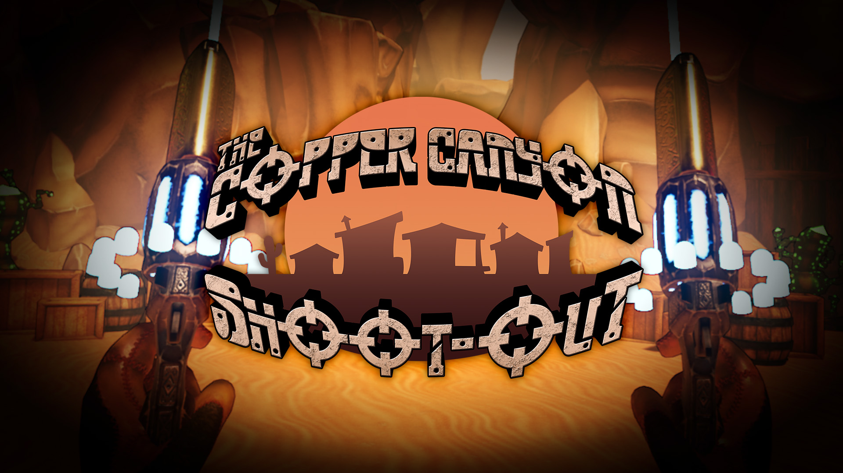

The Copper Canyon Shoot Out

Press Kit

Welcome to the press kit for The Copper Canyon Shoot Out. Here you can find all information and resources related to both The Copper Canyon Shoot Out and the developer Black Dragon Studios Ltd. For the purpose of evaluating and reviewing the game.

Fact Sheet

- Developer: Black Dragon Studios, based in Swansea, UK

- Website: www.blackdragon-studios.com

- Release: April 30th 2019 (Windows 7 / Windows 10)
June 14th PSVR (EU)
July 19th PSVR (America)

- Platforms: Steam / HTC Vive / Oculus Rift / PSVR

- Price: £9.99 (UK)
$9.99 (USA)
€9.99 (EU)

- Rating: IARC 7+

- File size: Approx. 1GB

- Contact: devteam@blackdragon-studios.com

- Social: @BlackDragonDev
https://www.facebook.com/BlackDragonDev
https://discord.gg/hXdcqv5
https://www.instagram.com/blackdragonstudios_official/

Description

The Copper Canyon Shoot-Out is a VR shooter developed by Black Dragon Studios in Unreal Engine 4 for the Oculus Rift and HTC Vive.

Gameplay consists of frantic gun-based combat set in a Wild West themed world overrun by hostile robots. The Copper Canyon Shoot-Out has been designed to be played in relatively short bursts and offers an instant action, no-strings VR experience that can be played from either a standing or sitting position (standing recommended).

The core of the game is extremely fast and frenetic. The player must progress through three levels that are each divided into multiple areas. In each area the player must face relentless waves of enemies which spawn around the environment in progressively more challenging waves. Enemies will dynamically take cover, charge or attack independently.

The player is encouraged to continually move from cover to cover whilst laying down as much fire as possible, giving the game a real Wild West shoot-out atmosphere. Using dual-wield weapons, multiple enemies can be engaged at once and the air is often filled with bullets (which can be shot down). Each path leads to a final open arena where the player must face a final boss which will present different challenges depending on the chosen level and must be defeated in stages, destroying limbs and body parts.

Features

- Colourful and stylised Wild West era world
- Unique environments: the Town, Desert Canyon and Crystal Power Mines
- Immersive bullet-dodging VR action
- Multiple enemy types with a variety of challenging attacks
- Multi-stage boss that requires different tactics on each encounter
- Dual wield weapons in any combination
- Achievement challenges to complete
- Originally developed Western themed dynamic soundtrack reactive to game play

Narrative Synopsis:

Near the South Wales coastline, a western theme park called the Copper Canyon has been created. This park is staffed with robot actors who act out the major western cliché, to the enjoyment of audiences world-wide.

After a record 12 days without a major incident the Copper Canyon is beset by a new menace (other than the South Wales weather), the local Sheriff bot, Sheriff Bolts, and his deputies have malfunctioned (probably the rain) and taken over the town, the surrounding canyon and mines. Now the Copper Canyon’s owner Dai Davies is sending in his daughter Dixie to take out Sheriff Bolts and his deputies, and reclaim the theme park.

Gameplay Summary:

The Copper Canyon Shoot Out is a VR only game and must be played with the headset on at all times, the game also requires the use of motion controllers on all platforms. The player takes on the role of Dixie Davies and are tasked with entering the Copper Canyon and clearing out the rogue deputy bots and the sheriff.

The game’s primary control method is through the motion controllers these are used to pick up, hold and shoot the player’s weapons; the players hands are digitally represented through the motion controllers with each platform’s motion tracking. The player can also interact with some environment objects through the motion controllers, such as debris from exploded robots.

The core design for the Copper Canyon Shoot Out is that of a carnival tin can alley game turned up to 11, with fast paced shooting, immediate damage to the enemies when shot, and quick feedback from a successful hit. The player interacts with the majority of the world through shooting their guns as well, a level is selected through shooting, enemies destroyed, health picked up, checkpoints activated, and the level is completed through shooting; only the options menu and the pause menu can be interacted with without shooting.

Players traverse the levels of the game using a quick and simple teleporting mechanic. Players can teleport to anywhere on the ground in the level, and can teleport over geometry between them and their chosen destination. The player can also edit their teleported orientation, so that they are in full control over how they will teleport to their destination.

The Copper Canyon Shoot Out Screenshots

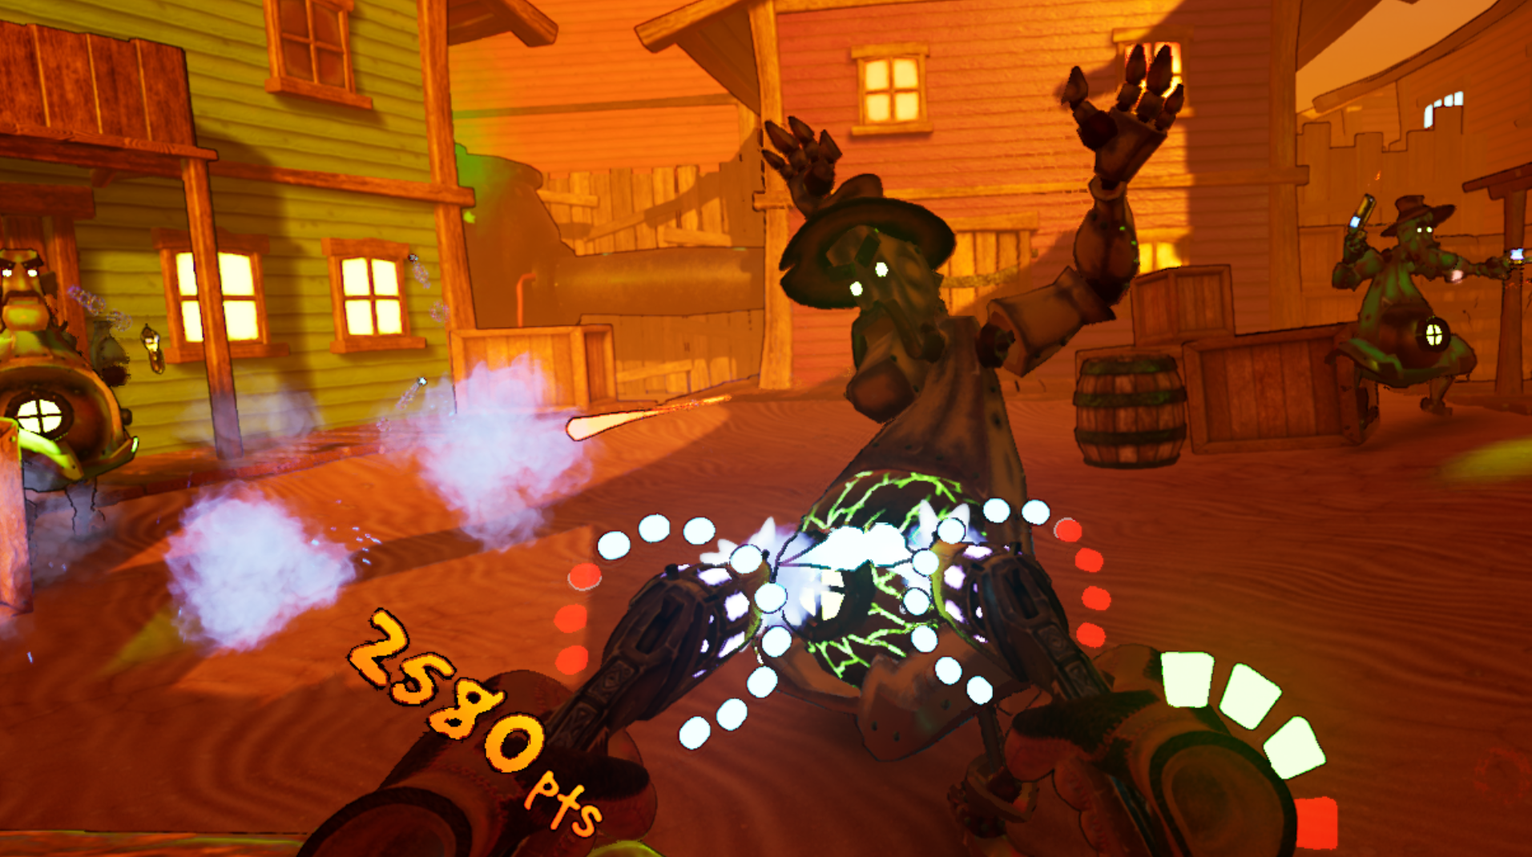
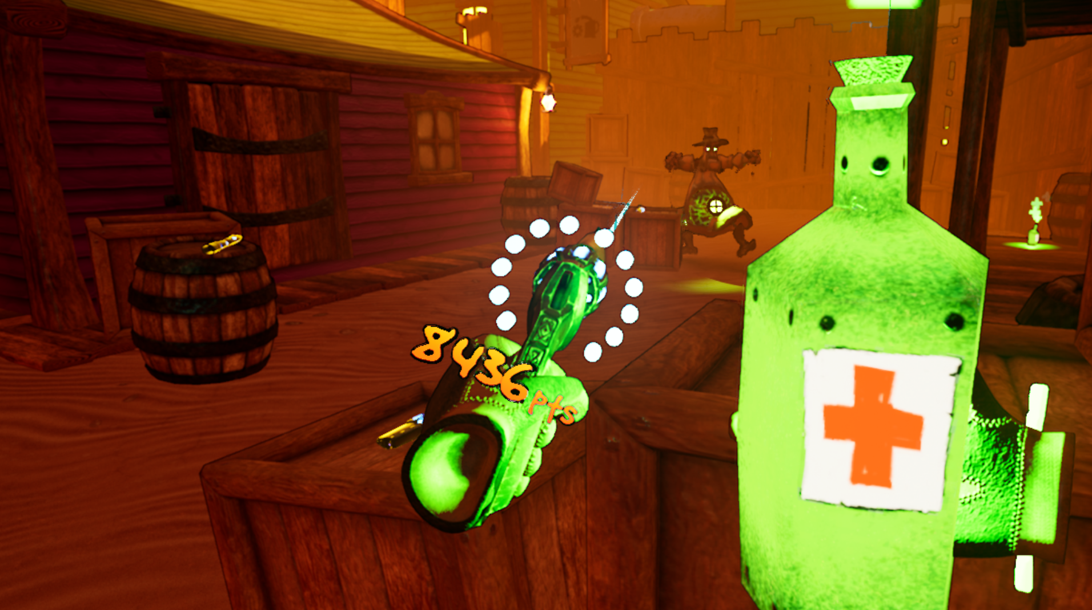

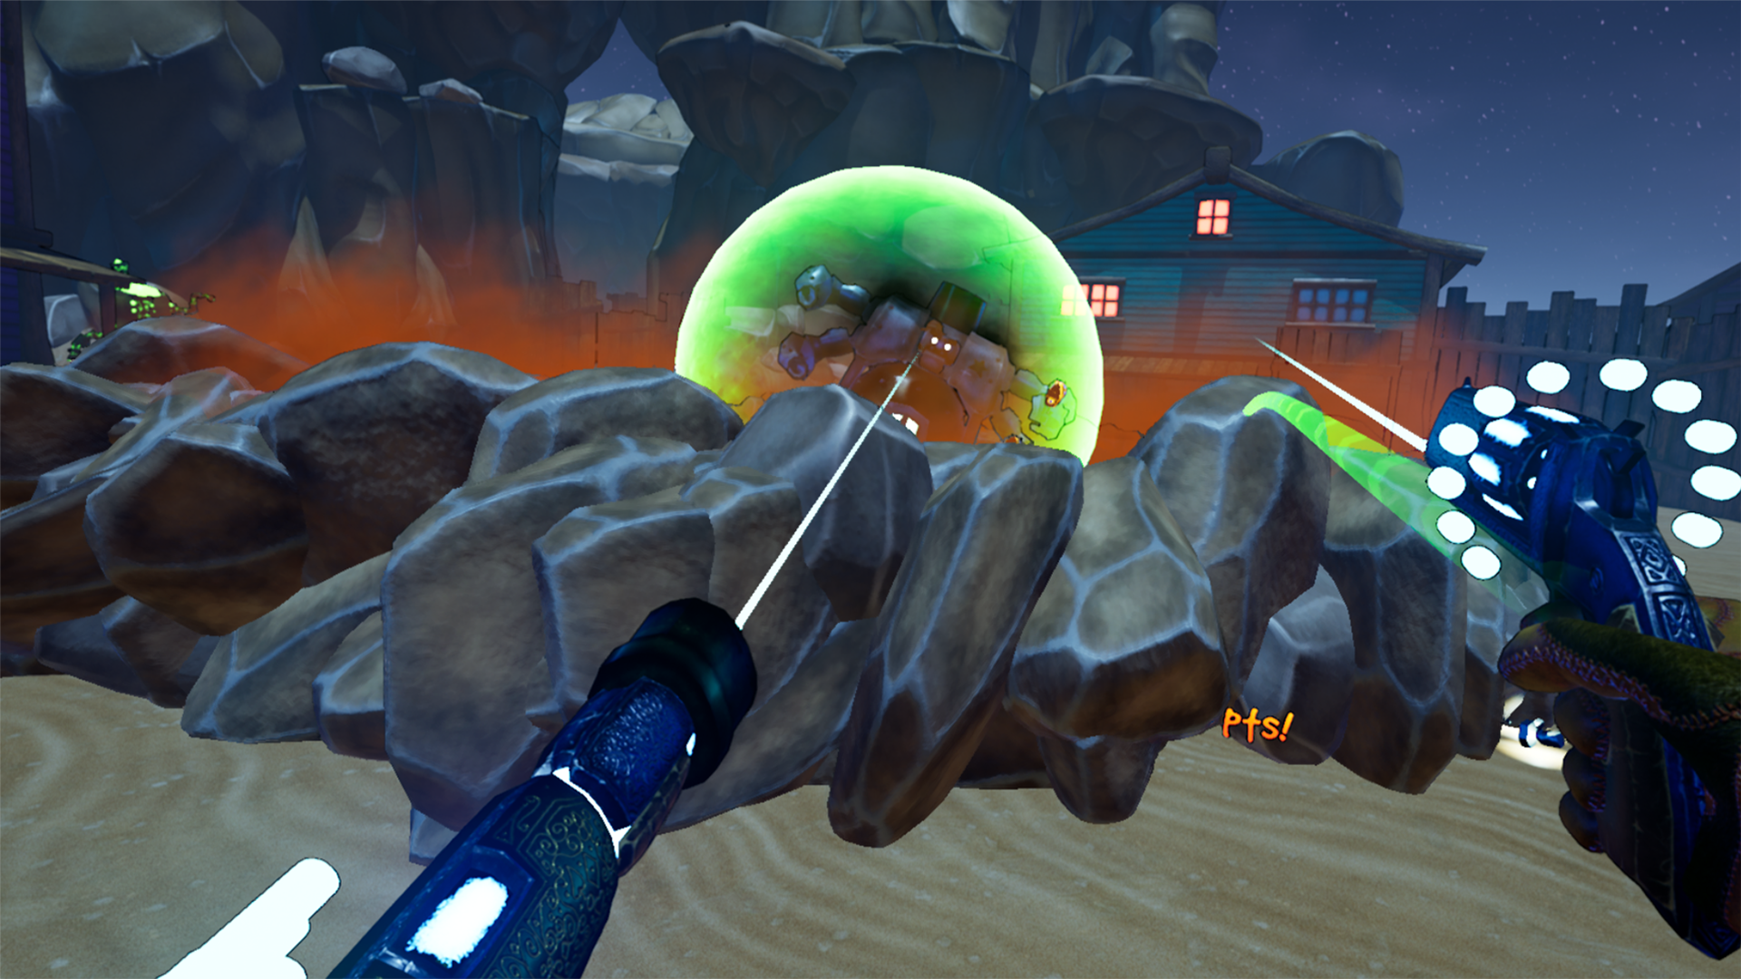
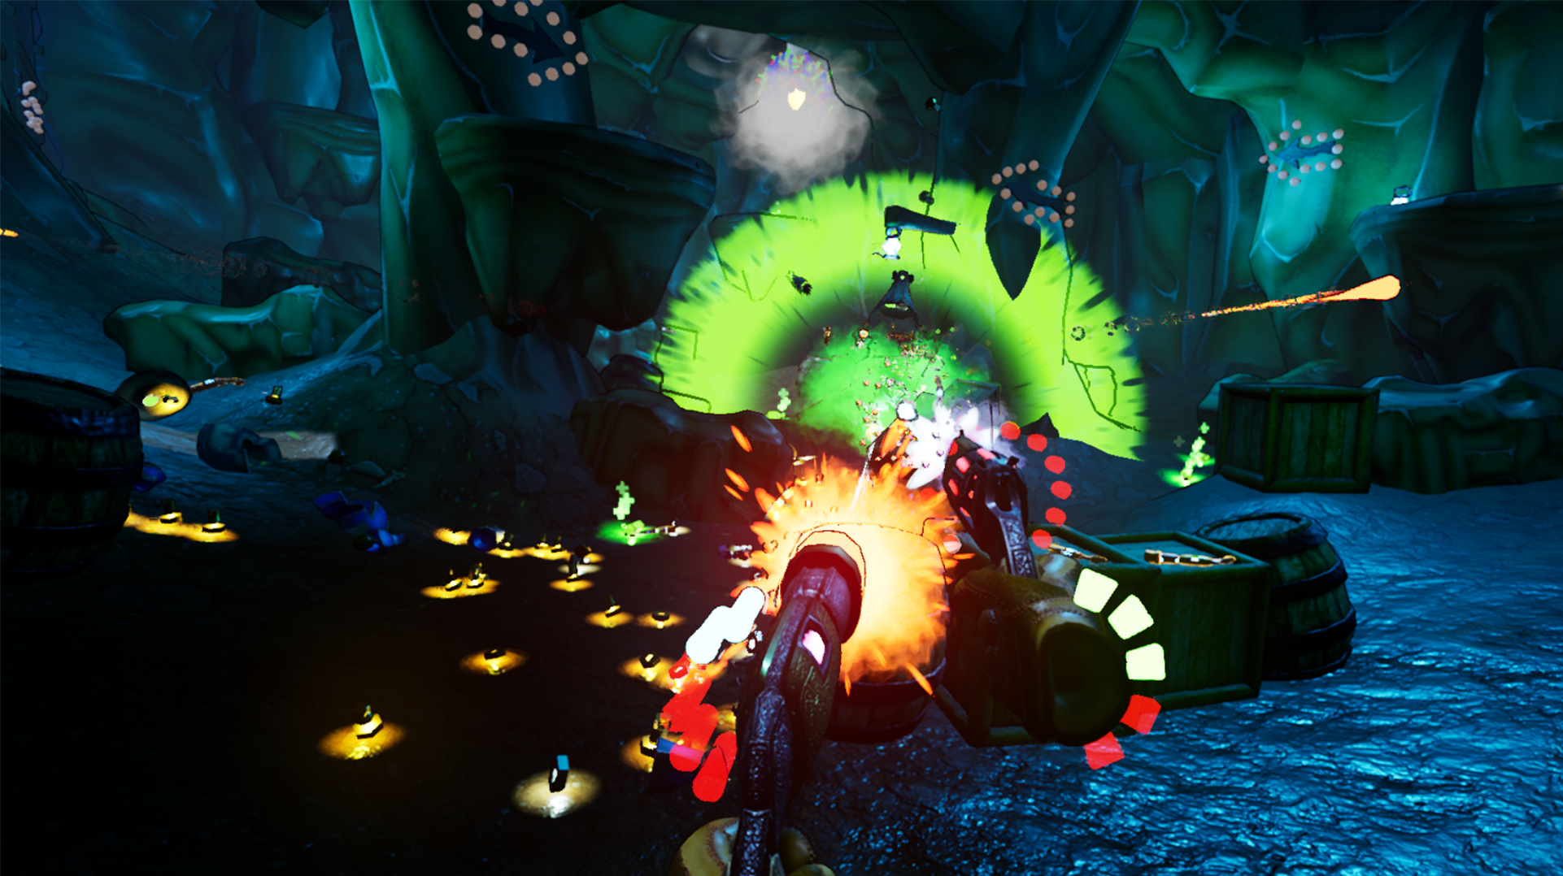
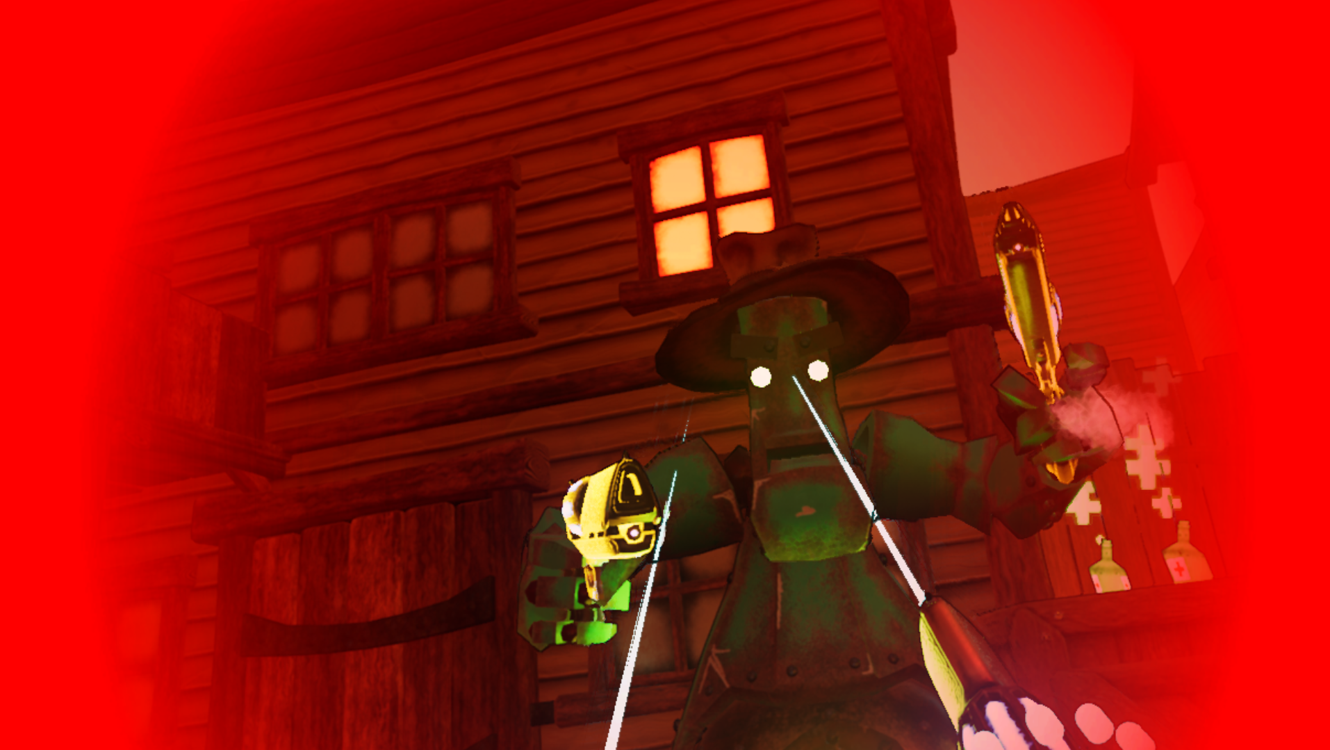

Screenshot download here (more extensive selection available for download)

The Copper Canyon Shoot Out videos

The Copper Canyon Shoot Out trailer

Trailer Download here

Logos

Below is a selection of useful game and studio logos for use in reviews or features:
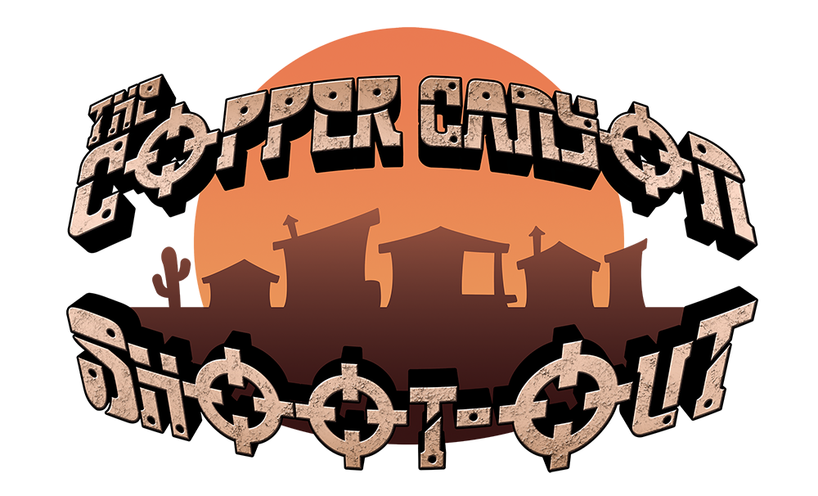

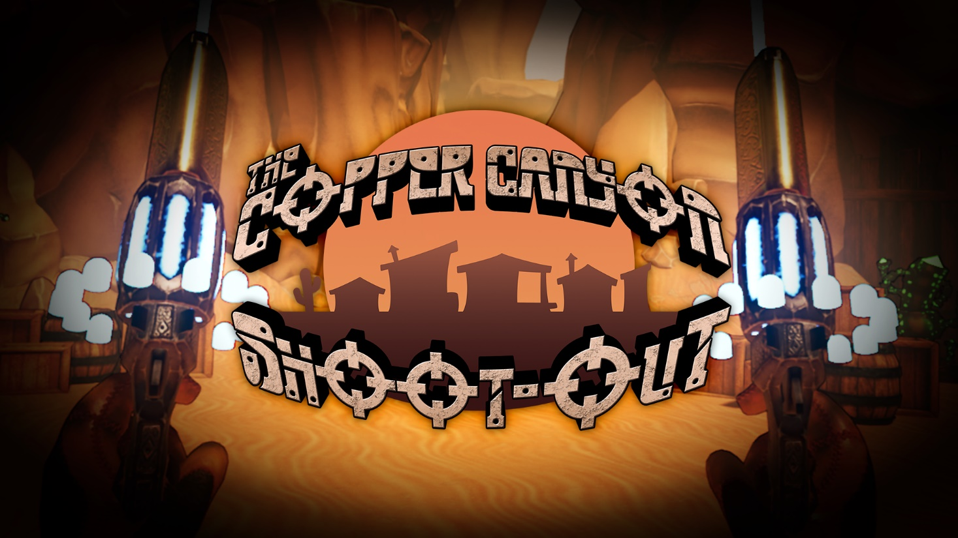

Black Dragon Studios overview

Formed in September 2018, Black Dragon Studios is a fully independent games developer. As a studio we create virtual and augmented exhibitions, educational experiences, and of course video games. Our team is made up of industry and academic experts who have a combined experience of over 20 years in practicing and teaching game design and development. Together we create video games for established platforms as entertainment products alongside digital heritage and digital preservation ventures, collaborating with museums, universities and other educational institutions.

Black Dragon Studios is:

Julian Hainsworth – Chief Technology Officer, Technical Artist

Julian Hainsworth taught Games Design for over five years at the University of Wales Trinity Saint David in Swansea. Julian has worked on several game titles as lead scripter/programmer including BAFTA CYMRU winning Go Candy.

Jon Carroll – Chief Executive Officer, Character Artist

Jon Carroll has 12 years of experience teaching Digital & Multimedia, 3D Computer Animation, and Games Design, delivering subjects in Environment and Level Design, Character Animation, Character Concepts, Asset Modelling, Character 3D digital sculpting and Texture art

Chris Davies – Chief Digital Officer, Technical Artist

Chris Davies has a strong background in audio production, from traditional instruments to experimental and alternative methods of audio production in music and sound effects. Chris continues to develop and advance the studio’s audio methodology and to expand the role soundscapes play in the player’s journey.

Inquires

Please direct all inquiries to email address: devteam@blackdragon-studios.com

All right reserved Black Dragon Studios 2019

